SEC Form 3
FORM 3 | UNITED STATES SECURITIES AND EXCHANGE COMMISSION  Washington, D.C. 20549  INITIAL STATEMENT OF BENEFICIAL OWNERSHIP OF SECURITIES  Filed pursuant to Section 16(a) of the Securities Exchange Act of 1934  or Section 30(h) of the Investment Company Act of 1940
  OMB APPROVAL
  OMB Number: | 3235-0104
  Estimated average burden
  hours per response: | 0.5
1. Name and Address of Reporting Person*  (Street) | 2. Date of Event Requiring Statement (Month/Day/Year)  08/01/2026 | 3. Issuer Name and Ticker or Trading Symbol  FOSTER L B CO [ FSTR ]  Foreign Trading Symbol
  Bowlin Jason Kyle
  (Last) | (First) | (Middle)
  C/O L.B. FOSTER COMPANY
  415 HOLIDAY DRIVE, SUITE 100
  PITTSBURGH | PA | 15220
  (City) | (State) | (Zip)
 |  | 4. Relationship of Reporting Person(s) to Issuer  (Check all applicable) | 5. If Amendment, Date of Original Filed (Month/Day/Year)
   | Director |  | 10% Owner
   | Officer (give title below) |  | Other (specify below)
  Senior Vice President - Rail
6. Individual or Joint/Group Filing (Check Applicable Line)
Form filed by One Reporting Person
Form filed by More than One Reporting Person

Table I - Non-Derivative Securities Beneficially Owned
1. Title of Security (Instr. 4) | 2. Amount of Securities Beneficially Owned (Instr. 4) | 3. Ownership Form: Direct (D) or Indirect (I) (Instr. 5) | 4. Nature of Indirect Beneficial Ownership (Instr. 5)
Common Stock | 6,582(1)(2)(3)(4) | D
Table II - Derivative Securities Beneficially Owned
(e.g., puts, calls, warrants, options, convertible securities)
1. Title of Derivative Security (Instr. 4) | 2. Date Exercisable and Expiration Date (Month/Day/Year) |  | 3. Title and Amount of Securities Underlying Derivative Security (Instr. 4) |  | 4. Conversion or Exercise Price of Derivative Security | 5. Ownership Form: Direct (D) or Indirect (I) (Instr. 5) | 6. Nature of Indirect Beneficial Ownership (Instr. 5)
1. Title of Derivative Security (Instr. 4) | Date Exercisable | Expiration Date | Title | Amount or Number of Shares | 4. Conversion or Exercise Price of Derivative Security | 5. Ownership Form: Direct (D) or Indirect (I) (Instr. 5) | 6. Nature of Indirect Beneficial Ownership (Instr. 5)
Explanation of Responses:
1. Includes 340 Performance Restricted Stock Units earned under the 2025-2027 Long Term Incentive Plan granted on 5/22/2025; those 340 Performance Restricted Stock Units will settle at the end of the performance period on December 31, 2027, upon certification by the Compensation Committee.
2. Includes 1,288 Performance Restricted Stock Units earned under the 2024-2026 Long Term Incentive Plan granted on 5/23/2024; those 1,288 Performance Restricted Stock Units will settle at the end of the performance period on December 31, 2026, upon certification of the Compensation Committee.
3. Includes an award of 1,368 restricted stock units (RSUs) which are settled in stock upon vesting and generally will vest ratably over a three-year period on the first, second, and third anniversaries of the date of the grant.
4. Includes an award of 1,786 shares of time-vested restricted stock which will vest in 33 1/3 increments on each of the first, second, and third anniversary of the dates of the grants.
Remarks:
 | /s/ Jason K. Bowlin by Maribel Castro, attorney-in-fact | 08/04/2026
 | ** Signature of Reporting Person | Date
Reminder: Report on a separate line for each class of securities beneficially owned directly or indirectly.
* If the form is filed by more than one reporting person, see Instruction 5 (b)(v).
** Intentional misstatements or omissions of facts constitute Federal Criminal Violations See 18 U.S.C. 1001 and 15 U.S.C. 78ff(a).
Note: File three copies of this Form, one of which must be manually signed. If space is insufficient, see Instruction 6 for procedure.
Persons who respond to the collection of information contained in this form are not required to respond unless the form displays a currently valid OMB Number.
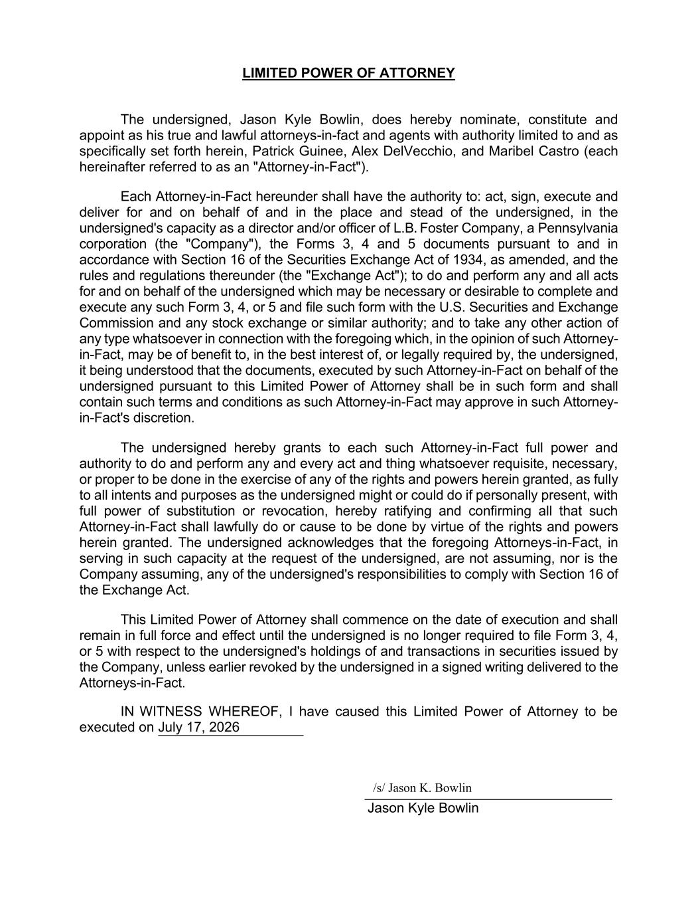
LIMITED POWER OF ATTORNEY The undersigned, Jason Kyle Bowlin, does hereby nominate, constitute and appoint as his true and lawful attorneys-in-fact and agents with authority limited to and as specifically set forth herein, Patrick Guinee, Alex DelVecchio, and Maribel Castro (each hereinafter referred to as an "Attorney-in-Fact"). Each Attorney-in-Fact hereunder shall have the authority to: act, sign, execute and deliver for and on behalf of and in the place and stead of the undersigned, in the undersigned's capacity as a director and/or officer of L.B. Foster Company, a Pennsylvania corporation (the "Company"), the Forms 3, 4 and 5 documents pursuant to and in accordance with Section 16 of the Securities Exchange Act of 1934, as amended, and the rules and regulations thereunder (the "Exchange Act"); to do and perform any and all acts for and on behalf of the undersigned which may be necessary or desirable to complete and execute any such Form 3, 4, or 5 and file such form with the U.S. Securities and Exchange Commission and any stock exchange or similar authority; and to take any other action of any type whatsoever in connection with the foregoing which, in the opinion of such Attorney- in-Fact, may be of benefit to, in the best interest of, or legally required by, the undersigned, it being understood that the documents, executed by such Attorney-in-Fact on behalf of the undersigned pursuant to this Limited Power of Attorney shall be in such form and shall contain such terms and conditions as such Attorney-in-Fact may approve in such Attorney- in-Fact's discretion. The undersigned hereby grants to each such Attorney-in-Fact full power and authority to do and perform any and every act and thing whatsoever requisite, necessary, or proper to be done in the exercise of any of the rights and powers herein granted, as fully to all intents and purposes as the undersigned might or could do if personally present, with full power of substitution or revocation, hereby ratifying and confirming all that such Attorney-in-Fact shall lawfully do or cause to be done by virtue of the rights and powers herein granted. The undersigned acknowledges that the foregoing Attorneys-in-Fact, in serving in such capacity at the request of the undersigned, are not assuming, nor is the Company assuming, any of the undersigned's responsibilities to comply with Section 16 of the Exchange Act. This Limited Power of Attorney shall commence on the date of execution and shall remain in full force and effect until the undersigned is no longer required to file Form 3, 4, or 5 with respect to the undersigned's holdings of and transactions in securities issued by the Company, unless earlier revoked by the undersigned in a signed writing delivered to the Attorneys-in-Fact. IN WITNESS WHEREOF, I have caused this Limited Power of Attorney to be executed on July 17, 2026 Jason Kyle Bowlin /s/ Jason K. Bowlin

